Architecture Document
BioVerse – AI-Assisted Secure DNA Data Encoding System
- Selected Architecture Type

Monolithic Architecture
BioVerse is implemented as a research-oriented prototype where all core components are tightly coupled and executed within a single application runtime. This approach is ideal for academic projects because it:
- Simplifies development and debugging
- Reduces deployment and operational complexity
- Supports rapid experimentation and iteration
- Allows tight integration between cryptography, encoding, ECC, AI, and UI modules
Although future extensions may refactor the system into microservices, a monolithic architecture is the most appropriate choice for a proof-of-concept research system.

2. Application Architecture Overview
The BioVerse application consists of multiple logical modules that operate within a single monolithic system:

Core Modules

1. File Handling Module
The File Handling Module is responsible for reading input files of any format and converting them into raw byte streams for further processing. It also manages the reconstruction and storage of decoded output files, ensuring that file integrity and original format are preserved throughout the encoding and decoding process.

2. Cryptography Module (AES)
The Cryptography Module ensures data confidentiality by encrypting digital data using the Advanced Encryption Standard (AES). Encryption is applied before DNA encoding so that even if encoded DNA is accessed, the original data remains unreadable without the correct cryptographic key.

3. Error Correction Module (Reed–Solomon ECC)
The Error Correction Module improves robustness by applying Reed–Solomon error correction to encrypted data before DNA encoding. This allows the system to recover original data even if minor errors or mutations occur in the DNA sequence during storage or transmission.

4. DNA Encoding / Decoding Module (Bio-Constrained)
The DNA Encoding and Decoding Module converts binary data into DNA sequences using a biologically-constrained rotation cipher. Unlike a simple fixed nucleotide mapping, the constrained encoder enforces three biological synthesis rules simultaneously: (1) homopolymer run limit of 3 (no more than 3 consecutive identical bases), (2) GC-content balance between 30-70% in every 20-base sliding window, and (3) avoidance of five common restriction enzyme recognition sites (EcoRI, BamHI, HindIII, XhoI, EcoRV). When a naive 2-bit base mapping (00->A, 01->T, 10->G, 11->C) would violate a constraint, the base is rotated cyclically (A->T->G->C->A) up to 3 times. The rotation counts are stored as sideband metadata in the DNA file header, enabling lossless reversal during decoding. This approach guarantees synthesis-compatible DNA output for any input data.

5. AI DNA Generation & Watermarking Module (Dual-Purpose)

The AI DNA Generation and Watermarking Module uses an LSTM neural network (trained on real genomic sequences from Homo sapiens chr1, Escherichia coli, and Arabidopsis thaliana) to generate biologically realistic 120-base DNA fingerprints. A Markov chain fallback is provided for environments where TensorFlow is unavailable. The module now serves a dual purpose: (1) Biological Camouflage - the AI-generated fingerprint is concatenated with the encrypted payload to shift overall sequence statistics toward natural genomic DNA patterns; and (2) Integrity Hash Embedding - a SHA-256 hash of the payload DNA (first 32 hex characters) is encoded as DNA bases using a 4-to-1 hex-to-base mapping and inserted into the fingerprint between AGTC marker sequences. During decoding, the embedded hash is extracted and compared against a freshly computed hash to detect tampering. This eliminates the need for external checksum files.

6. User Interface Module (Streamlit)
The User Interface Module provides an interactive web-based interface built using Streamlit with four functional tabs: (1) Encode - upload any file, encode to DNA, view constraint compliance and camouflage metrics; (2) Decode - decode a DNA file, verify integrity, recover the original file; (3) Analyze - analyze any DNA sequence for biological realism and base distribution; and (4) Evaluate - run full benchmarks with comparative metrics across five dimensions. Uploaded files are automatically deleted after processing for privacy, and the output directory is cleaned before each new operation.
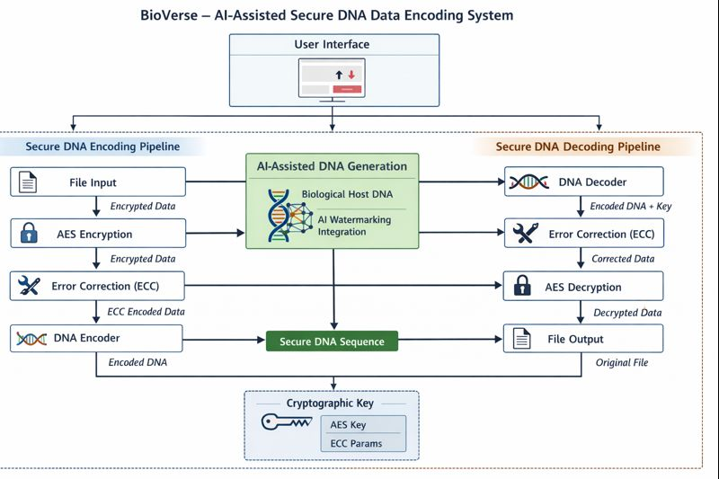
7. Bio-Constraints Module
The Bio-Constraints Module (core/bio_constraints.py) is a new module introduced to handle all biological constraint verification and enforcement. It implements the rotation cipher encoding/decoding logic, constraint checking (homopolymer, GC-content, restriction enzymes), rotation flag packing/unpacking, and constraint compliance statistics computation. This module is called by the DNA Encoding Module to produce synthesis-compatible sequences.
8. Evaluation Framework Module
The Evaluation Framework Module (core/evaluation.py) is a new module that produces standardized quantitative metrics across five dimensions: (1) Storage Efficiency - encoding density in bits per base; (2) Security - AES key space analysis; (3) Error Correction Resilience - Reed-Solomon correction capacity; (4) Biological Realism - GC-content, Shannon entropy, base balance, and composite realism score; and (5) Pipeline Performance - encoding/decoding throughput. It also includes a naive-vs-constrained comparison that quantifies the improvement from bio-constrained encoding. This module enables reproducible benchmarking and IEEE-ready evaluation.
Each module performs a distinct responsibility while sharing the same execution environment. The system now comprises 8 logical modules operating within a single monolithic runtime.
- Architecture Type Analysis

3.1 Application Architecture
- Type: Monolithic
- Execution Model: Single-process Python application
- Interaction: Function calls and shared memory
- Deployment: Local system / academic environment

4. Database Architecture
No persistent database is used in the current implementation.

Reasoning
- The system processes files in-memory or via temporary filesystem storage
- No long-term data persistence is required
- Reduces security risks associated with storing sensitive data
This design choice aligns with the research and security-focused nature of the project.

7. Data Exchange Contract

Internal Data Exchange
Data exchange occurs internally within the application between modules.
From Module | To Module | Data Type
File Handler | Cryptography | Raw bytes
Cryptography | ECC | Encrypted bytes
ECC | DNA Encoder | ECC-encoded bytes
DNA Decoder | ECC | Binary data
ECC | Cryptography | Corrected encrypted bytes
Cryptography | File Handler | Original file bytes
DNA Encoder | Bio-Constraints | Binary + constraint params
AI Watermark | DNA Encoder | Fingerprint with integrity hash
Evaluation | All Modules | Metrics and benchmarks
All data exchanges use in-memory Python objects.

8. Frequency of Data Exchanges
Operation | Frequency
File Upload | On user action
Encryption | Once per file
ECC Encoding | Once per file
DNA Encoding | Once per file
Decoding Pipeline | Once per decode request
The system is user-driven, not continuously running.

9. Data Sets

Implemented Data Sets
- User-provided digital files (text, image, audio, video, executable)

Proposed Data Sets (AI Module)
- Public DNA sequences from genomic databases (e.g., GenBank, NCBI)
- Used only for training AI models to learn DNA base patterns

10. Mode of Data Exchange
Interaction | Mode
UI → Core Logic | Function call
Core → UI | File output
Encode/Decode | File-based
AI Module | File / Memory
No external APIs or message queues are used.

11. Required Diagrams

11.1 Use Case Diagram

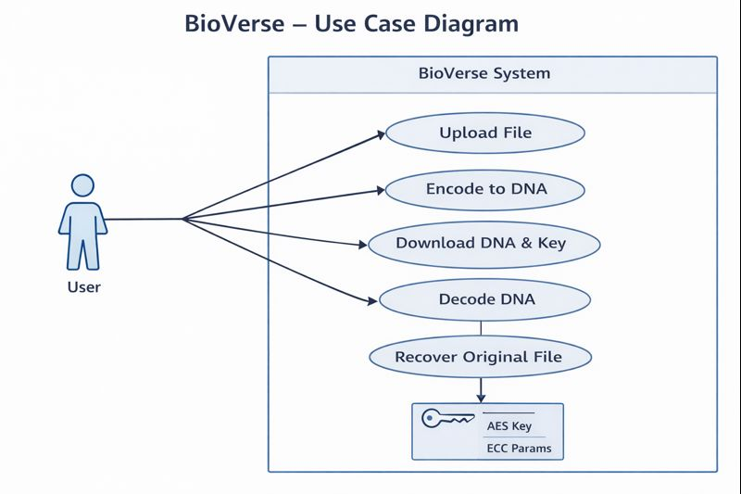

11.2 Data Flow Diagram (DFD – Level 1)

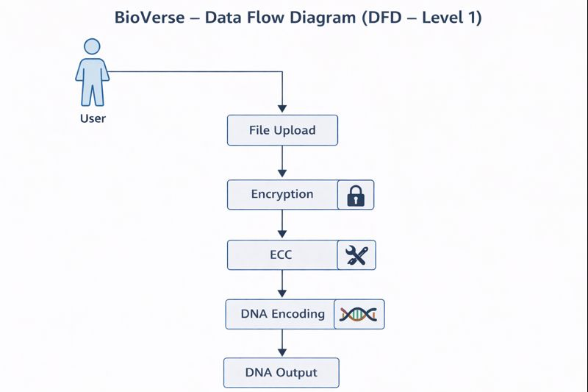

11.3 Component Diagram
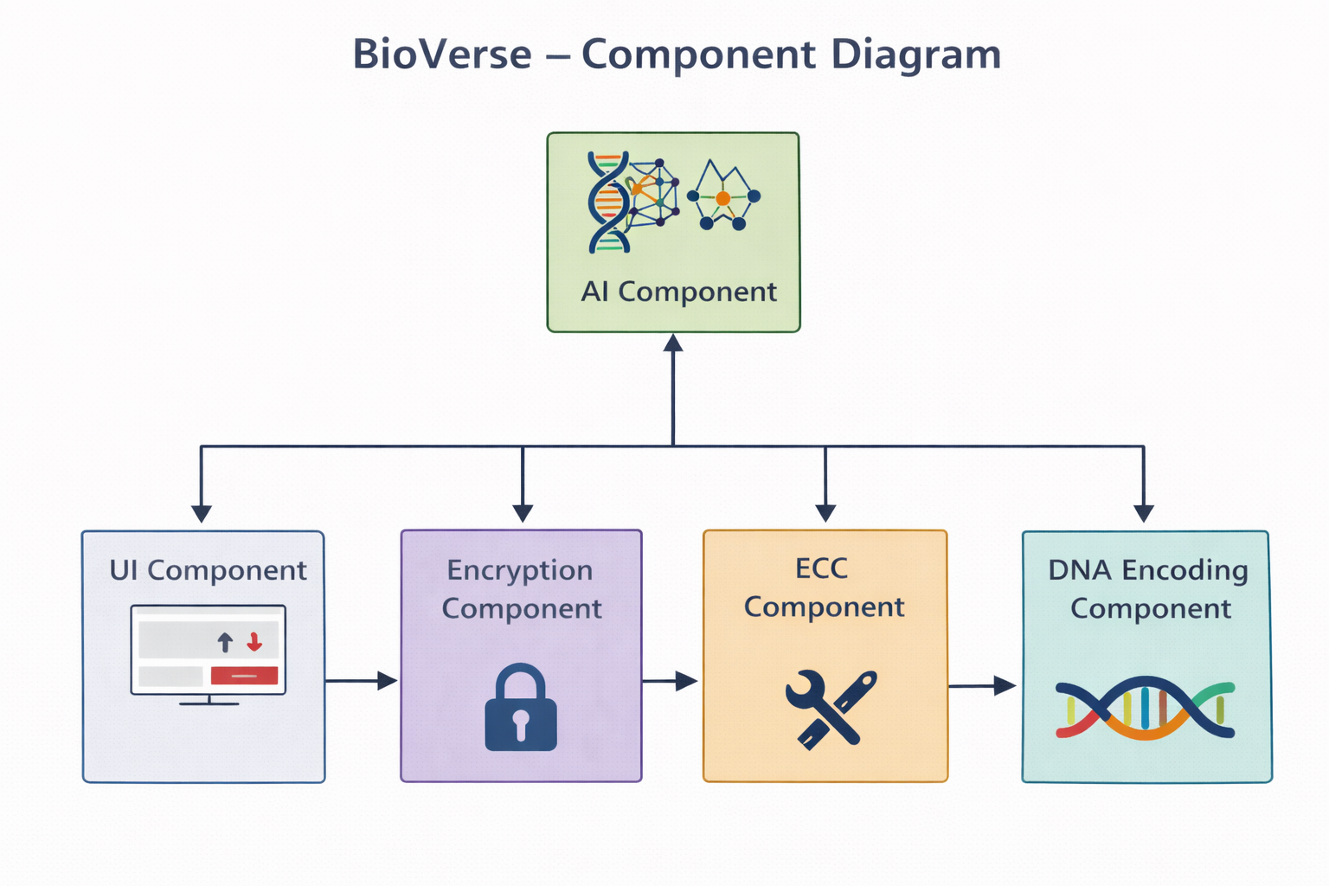

11.4 Sequence Diagram (Encode)

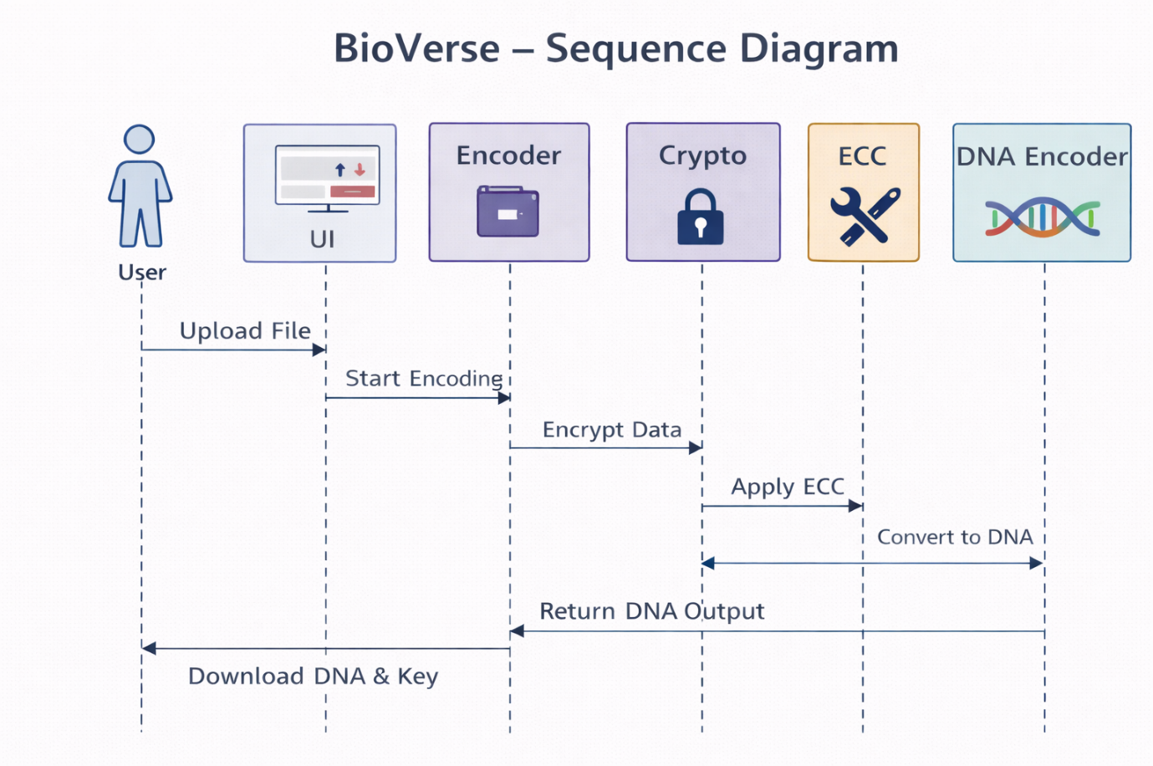

11.5 Deployment Diagram
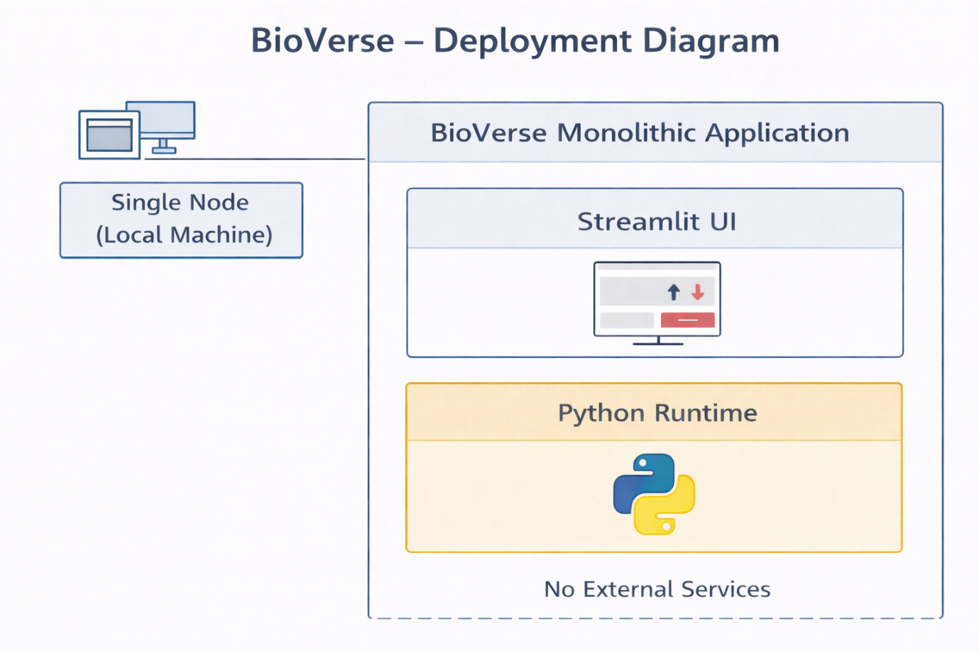
11.6 DNA File Format
The output DNA file uses a structured format with five fields: FINGERPRINT (AI-generated DNA watermark with embedded integrity hash), ROTATIONS (hex-encoded rotation flags for constrained decoding), ROTATION_COUNT (total number of encoded positions), HASH (SHA-256 hash of payload, first 32 hex characters), and PAYLOAD (encrypted, ECC-encoded file data as DNA nucleotides).

12. Architecture Strengths
- Simple and explainable
- Secure by design
- Research-friendly
- Easy to extend with AI
- Suitable for academic evaluation

13. Architecture Limitations
- Not horizontally scalable
- File size overhead due to DNA representation
- AI components are now fully integrated into the encode/decode pipeline
These are acceptable trade-offs for a research prototype.

14. Future Architecture Enhancements
- Modularization into microservices (future research)
- AI-based DNA watermark embedding (COMPLETED - now implemented as dual-purpose watermark)
- Distributed DNA storage simulation
- Performance optimization via chunking

